

**Faculty of engineering - Shoubra**

**Benha University**

|  |  |  |  |
| --- | --- | --- | --- |
|  | Name | Edu mail | B.N |
| 1 | **بسنت وائل السيد سيد احمد شلبي** | bassant195281@feng.bu.edu.eg | 257 |

**TOBIC: Programming languages**

**Course Code: ECE006**

* **Programming Languages brief :**

Programming is the writing of a set of commands, or what is known as the code or code, and these commands are what constitute what is known as the program, it is what guides and determines its behavior. A computer or electronic device translates these commands and executes them.

Programming languages, which are a group of electronic languages that are used with systems and digital applications that work in computer and smart electronic devices, and that aim to build a system, application, or Internet page, and programming languages are also known as electronic operations that aim to assemble and install a group of Data together to fix something in an electronic system, or to build a new system used in an application, or a website.

* **Screenshots:**

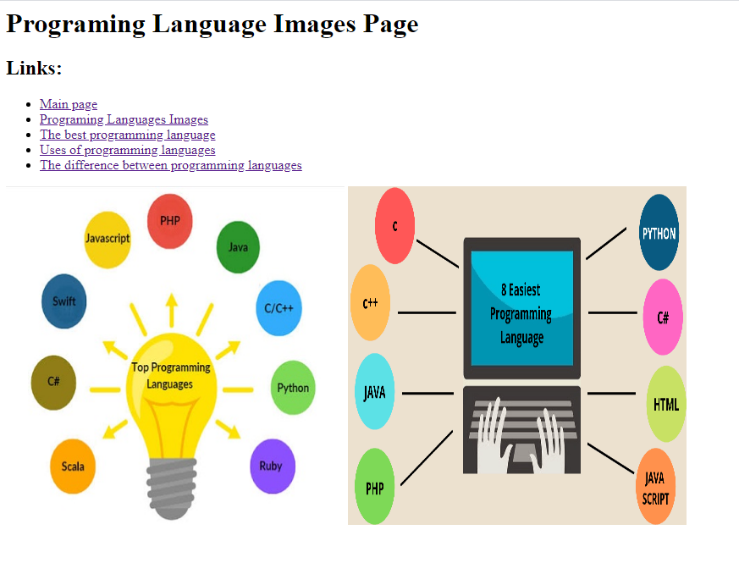

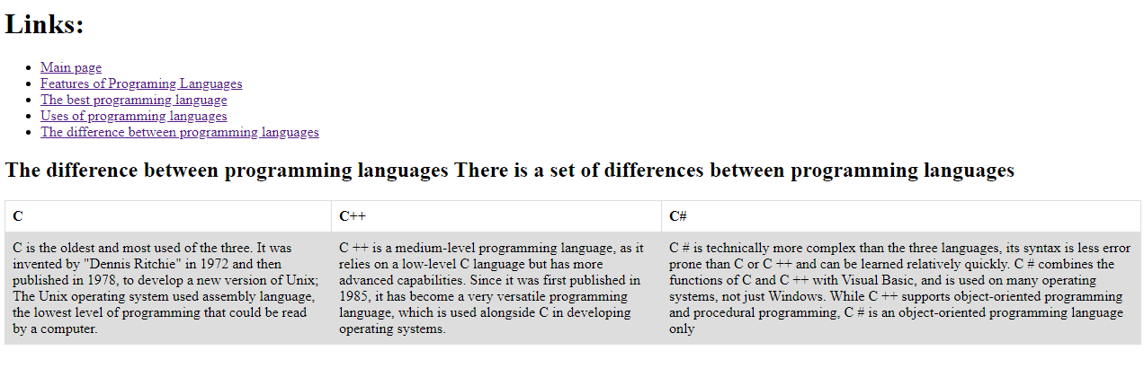

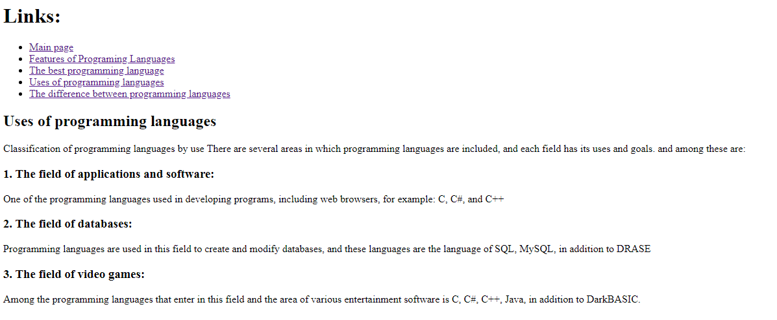

* **Sourec code:** 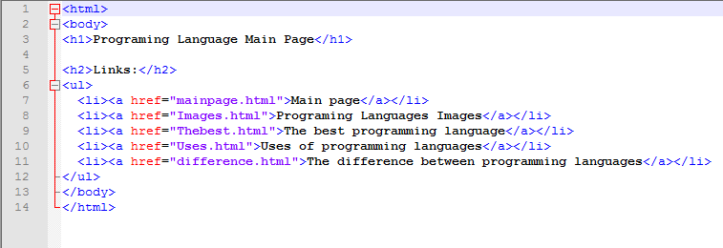

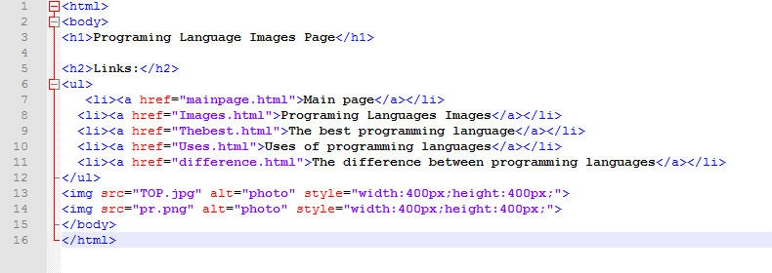

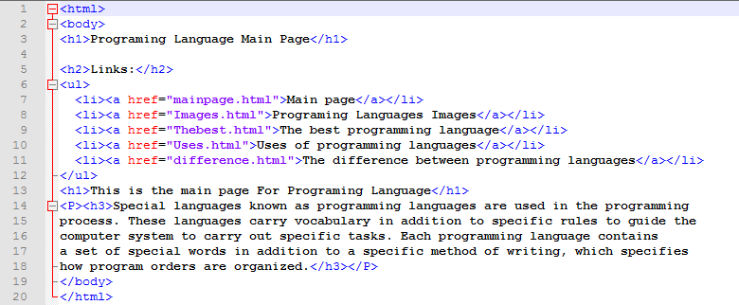

**References**

<https://www.computerscience.org/resources/computer-programming-languages/?fbclid=IwAR1MCL7GLA78qWYhSnu_u9kSZhYlWsnGlKzRgAOasOs7IVqa_c8UR-F5iPs>

<https://www.fullstackacademy.com/blog/nine-best-programming-languages-to-learn?fbclid=IwAR2gFZgxI1BAycCiL-MQduaR2kZJbRwrJDTcw78dOssQC0enjbQWh00jnRI>

<https://www.britannica.com/technology/computer-programming-language>

<https://www.coursera.org/learn/programming-languages?fbclid=IwAR2BXeipYZEWeRNI26rANQG7NLXsTPa5wZH_K1nsDXej_XEIm-nvmjP7jLM>